Writing for Broadcast

WSLS News Channel 10’s Juliet Bickford delivers the news from her anchor desk. Broadcast stories are written to be read aloud. They should rely on short, clear sentences. WSLS News Channel 10/used by permission
Introduction
In this chapter you will begin to work on brief stories written for broadcast. It is beyond the scope of this text to offer you full-fledged training as broadcast journalists. In subsequent courses you may well learn to gather and edit sound and video to produce stories for radio and television, and to “write to tape” – that is, build a story script around the visual images you have gathered. For now, we will focus on stories read by anchors and not accompanied by video. Called “Readers,” or RDRs (but also pronounced “readers”), these almost never run longer than 30 seconds.
Why 30 seconds?
Remember that, while The Jeffersonville Herald has a local edition that circulates only in Blue Ridge and one adjoining county, Channel 5’s newscast covers an area of about 100 miles up and down the valley from Jeffersonville. TV stations don’t do “zoned” broadcasts. Viewers in Steubenburg and Wilson will see the same newscast as viewers in Valleydale and Jeffersonville, so stories that go on the air have to appeal to all those viewers, and air time to cover such a vast area is at a premium. That means that Tori must be brief when she writes about her communities for the broadcast, especially when she has no video to accompany her stories. Television is a visual news medium, so with no visual elements even a compelling story must be told quickly.
By looking first at RDRs, you should gain an understanding of how and why broadcast writing differs from writing for print and online media – even social media that might be even more condensed than broadcast. With that foundation, you should be prepared for later courses that involve shooting, editing, and writing to video.

A broadcast scripts
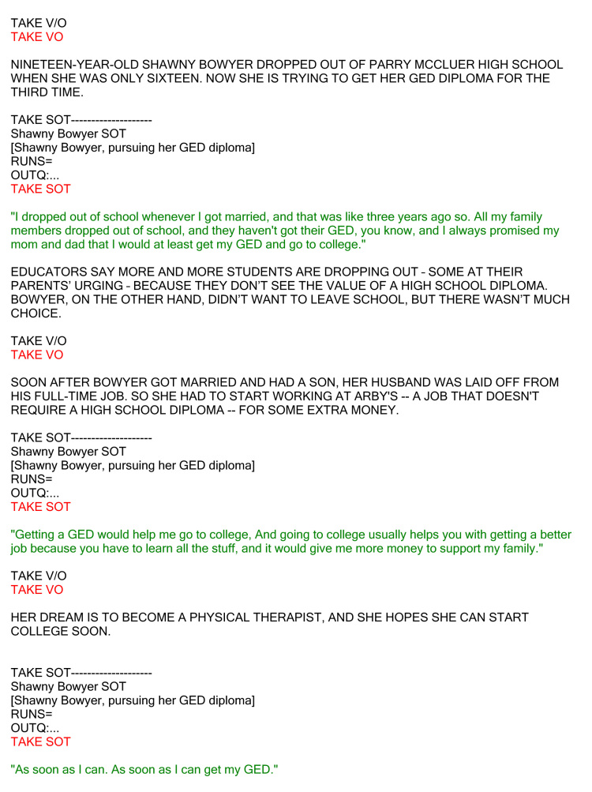
A script for a full broadcast package indicates video, sound bites and other elements. Writing a 30-second RDR can be just as challenging.

What makes good broadcast writing?

- Good broadcast writers use words that sound good. They also use words that evoke images, even when they know that visual elements will dominate their story. Try reading this aloud, from a story by NBC correspondent Steve Dotson about a cave rescue that had plenty of video:
“Imagine slithering through a block of swiss cheese a mile and a half long. Climbing up a thousand-foot maze dragging a broken leg. That’s what it was like for Emily Mobley. She clawed her way beneath the earth for four days, after an 80-pound boulder slipped and crushed her in a cave . . .. “
Or “this, from the late CBS correspondent Charles Kuralt, about Little Big Horn:
This is about a place where the wind blows, the grass grows, and a river flows below a hill. There is nothing here but the wind and the grass and the river. But of all places in America, this is the saddest place I know. “

That’s a great story, even before you have seen the video. You can’t wait to learn why such a simple place can be so sad.

- Good broadcast writers know that much of the appeal of most of their stories will be emotional, because they will reach a bigger audience than just those who will be affected rationally. That affects their impact, elements, words decisions significantly.
- Good broadcast writers use words that can capture an audience and create understanding the first time. A broadcast audience does not have the option of re-reading a sentence that was hard to follow.
- Good broadcast writers know someone has to read what they wrote aloud, on the air. They avoid most multiple-syllable words, words that are tough to pronounce, and long, convoluted sentences.
- Good broadcast writers cut to the chase quickly, but in a conversational style. After all, their audience will see and hear someone telling them the story, much as in a conversation. But, unlike in a conversation, no one will answer the news reader, and the “conversation” will be much, much shorter. A 30-second RDR, for example, takes up only about seven lines as a computer file.

Writing the RDR – a familiar process
Remember the writing process we have been working on since the beginning. Think before you write. Find the impact and the elements, and then wrestle with the words. Writing for broadcast, like all good writing, begins with thinking about your audience, and how information will affect that audience.
For example, your lede, story focus, and details about a bus driver strike in New York City will be different for an audience in Jeffersonville than for one in New York, so you will probably make different decisions about impact and elements. The Jeffersonville piece might quickly tell viewers that 6,000 New York bus drivers called in sick today, leaving hundreds of thousands of commuters stranded. Both stories will focus on the what – the work stoppage. But in the Jeffersonville story the primary who will be the bus drivers, who will evoke either sympathy or anger – emotional impact – from your audience. In New York, the primary who becomes the commuters who were stranded. Commuters are your New York audience, and they’re affected rationally by the strike. Both stories would probably include one or two more brief sentences on why the bus drivers are striking – the contract issues. It is in the way we put words together that RDRs differ most from print stories.

Some Tips for RDRs
To help you with the brevity and more conversational style of broadcast writing, try the following:
Give your audience a few seconds to pay attention. Remember that broadcast audiences cannot re-read a story. Anything you write at the beginning of your RDR is apt to be lost when it is read aloud to viewers who haven’t decided yet whether they should listen. “In Valleydale tonight” is a terrible way to start a newspaper lead. But it can give a broadcast audience an essential attention cue, and give ears a chance to tune in to the story.
Locate your story for your audience right away. Again, telling audience members who might be 100 miles away at the outset that your story is from Beausoleil will help them make an immediate go/no-go decision on whether to pay attention.
Write as you speak, only better. Remember that radio and TV are conversational media. We begin by writing stories, but then we tell them orally. Tell your story to your audience as though you’re telling it to your best friend or your mother. Let’s say you saw a church burning in Valleydale. Would you say, “Mom, 150 years of history went up in smoke today . . . .”? Not unless your mother was a little strange. You’d say something like, “Mom, Valleydale Presbyterian Church is on fire. Its steeple is about to fall.” Use conversational language, but avoid slang and bad taste, and don’t insult the intelligence of your listeners or viewers.
Limit yourself to one thought per sentence. You’ll be able to develop clearer, more concise stories if you do. Keep not just your ledes but all your sentences to no more than 20 words. Strive for an average of about 15.
Make your RDR resonate without pictures. Using the right words often means using senses besides vision to show your audience what is going on. Read again the examples above from Steve Dotson and Charles Kuralt.
Write for the ear. Remember, a viewer or listener will hear the story rather than read it. Rely on the active voice, short sentences, short words, a conversational style. Avoid subordinate or relative clauses. Treat them instead as separate sentences, much as you would in a Web blurb:
Not: “Two people were killed today when a light plane, which had just taken off from Jeffersonville Regional Airport, crashed into a mountainside.”
Try instead: “Two people died in a plane crash near Jeffersonville this morning. The Cessna two-seater slammed into a mountain just after taking off from the regional airport.”
Look for ways to put the story in the present tense. Broadcast news strives for more immediacy than print news. But don’t lie; if an event has ended by the time you broadcast, put its aftermath in the present tense, not the event itself. “President Obama meets with his cabinet” may be okay as a five-second tease to a newscast, but if the meeting has already happened, focus your story on the result: “Cabinet members are refusing to comment on what happened during a four-hour meeting with President Obama this morning.” Another advantage of this approach is that by focusing on what is happening now you will probably convey the real impact of the story more effectively.
Avoid quoting people in RDRs. Remember that it is awkward or impossible for the anchor to convey when someone is being quoted. If you must use a quote, look for ways to do that clearly but stylishly:
Not the hackneyed: “The President said, and I quote . . . .”
Instead, try: “The president praised crew members for handling themselves — as he put it – ‘with such class and dignity.’”
Or: “The President added: ‘We appreciate your mission, but most of all we appreciate your character.’”
Read it aloud. Remember that an anchor has to read your story aloud, and an audience has to understand it the first time. Viewers or listeners can’t go back and read it again. The best way to get an anchor — or a viewer — to come after you with an ax is to write a sentence like this: “City Manager Ron Allen ‘Don’ Prentice, who has been tenaciously resisting efforts by two City Council members to secure his dismissal, today again refused to resign, saying he would fight to keep his job.” Sharpen your focus: “In Valleydale, City Manager Don Prentice is vowing to fight to keep his job. Two City Council members have tried repeatedly to force Prentice to quit. The latest effort came at last night’s City Council meeting.”
Now time yourself reading it aloud. RDRs should run no longer than 30 seconds. Again, that’s about seven lines, because the anchor will read at a pace of about four seconds per line.
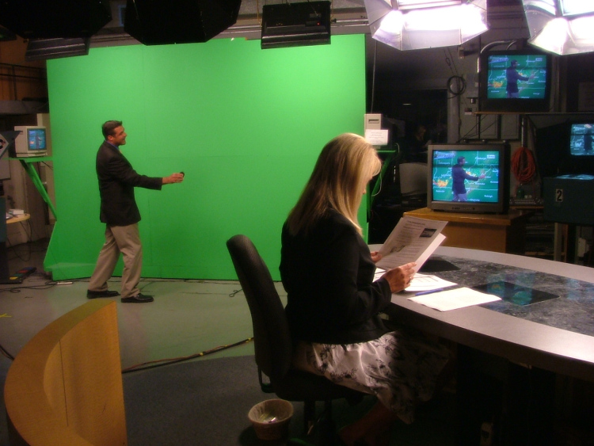
The sometimes-baffling technological requirements of broadcast news might require a special writing touch. WSLS News Channel 10/used by permission

Ethics
The focus of many discussions of ethics in broadcast journalism is on the intrusive nature of gathering information for electronic media. Even modern cameras are pretty noticeable, and the mechanics of shooting good video can mean that sources and subjects of stories feel as if they have been assaulted. I hope you have an opportunity to discuss the ethics of broadcast journalism more extensively in subsequent courses. But even if you are writing RDRs, without visual images to worry about, there are some ethical considerations to keep in mind.
First, the format itself creates some issues: Is 30 seconds enough time to give audiences a fair account of an event or issue? For some stories, it obviously is not. RDRs should be used for stories whose impact can be conveyed in three or four 15-word sentences. Where the event or issue is more complex, consider a longer package that includes video and sound bites.
Second, in striving for a conversational tone, are we trivializing a story or ridiculing the people in it? There is a difference between a conversational tone and inappropriate light-heartedness, mocking or sarcasm.
Third, as I mentioned earlier, do the characteristics of broadcast writing give audiences a false impression of events or the timing of action? The most obvious example is the focus on present tense in RDRs: “Beachgoers find their favorite seashore infested with sharks” is fine if the sharks are still there. If we are still using present tense to “freshen” a story that described the situation yesterday, we might be misleading our viewers and causing unnecessary concern.
Fourth, as in print writing, are we careful to make the words serve the facts? In making our writing as compelling as possible, there is a constant temptation to outrun what we know.

Strategies
Familiarize yourself with this summary of our tips for writing effective broadcast RDRs:
1. As you do when you write for print, find the impact and the elements, and then wrestle with the words that will show.
2. Give your audience a few seconds to pay attention. Remember that broadcast audiences cannot re-read a story.
3. Locate your story for your audience right away.
4. Write as you speak, only better.
5. Limit yourself to one thought per sentence. And strive for an average sentence length of about 15 words.
6. Make your RDR resonate without pictures.
7. Write for the ear. Remember, a viewer or listener will hear the story rather than read it.
8. Look for ways to put the story in the present tense. But make sure you are reflecting what is truly happening now.
9. Avoid quoting people in RDRs.
10. Read it aloud. Remember that an anchor has to read your story aloud, and an audience has to understand it the first time. Viewers or listeners can’t go back and read it again.
11. Time yourself reading it aloud. RDRs should run no longer than 30 seconds.

Strategies for Writing 30-second RDRs
1. Remember: Impact, elements, words.
2. Give your audience a few seconds to pay attention. Locate your story to let give individual viewers or listeners know whether they should pay attention. Otherwise, though, leave crucial information out of the first few words. Remember that broadcast audiences can’t re-read a lede.
3. Write just a little more formally than you speak. Try for a conversational tone.
4. Keep your sentences to about 15 words. Don’t clutter them with multiple facts.
5. Make your story resonate without pictures. Even though you are writing for broadcast, don’t assume that images will accompany your story. Brief RDRs often don’t use them.
6. Write for the ear. It is not enough for your story to make sense; it should sound good.
7. Put the story in the present tense, but only if you can do that without deceiving your audience.
8. Avoid writing quotes for the anchor to read. If you must use one, convey clearly when someone is being quoted.
9. As you work through successive drafts, read every one aloud.
10. Time yourself reading your final version aloud. If it runs longer than 30 seconds, tighten it. Don’t try reading it faster.

Exercise Five: A RDR
Use Exercise Five to help you understand the differences between writing for print and for broadcast. Try writing the story for print first, then for broadcast.
If you are like many of my students, your first try at the broadcast story will simply look like the first several sentences of the print story. Is that good enough? What can you do to serve your broadcast audience better? (Hint: Think about getting your broadcast lede into the present tense.)
Are you writing for the same audience? Will you structure the story the same for both audiences? What will be in the print story that you will leave out of the broadcast story? How will you choose words differently for the two stories?
Write a RDR for today’s 6 p.m. newscast from the following set of facts. Make sure your story runs no longer than 30 seconds on the air. That means you will have to weigh the information carefully, because you can’t possibly include it all. Remember your audience and your medium, and remember to read your copy aloud as you work. Time yourself reading the story aloud. At the top of the story, write in the number of seconds it runs. Remember also to use your City Directory to check local names.
Emergency situation today at Blue Ridge County High School.
15-degree (Fahrenheit) temperatures thought to be a factor.
Blue Ridge County High School and school board officials will not comment.
All students were walked to the parking lot of the North Service Authority one half-mile away, where buses took many home.
Buses could not go near the high school for fear of causing an explosion.
Propane gas leak detected at 10:40 a.m.
Leak appeared to come from one of two 5,000-gallon tanks behind the school.
No injuries reported, but one janitor is still unaccounted for. He has not been identified.
County fire-rescue squad’s Hazardous Materials Response Team responded, but hampered because they could not drive their equipment near for fear of explosion.
Shut-off valves occasionally fail in very cold weather.
LP gas is heavier than air, so it doesn’t dissipate quickly.
Area was still not reported secure as of 5 p.m.
Traffic on Route 15 near the high school was rerouted to Interstate 88, causing 3-mile jams in the north- and southbound lanes of the interstate until 3:30 p.m.
Source: https://processofwritingnews.wordpress.com/chapter-five-writing-for-broadcast/

