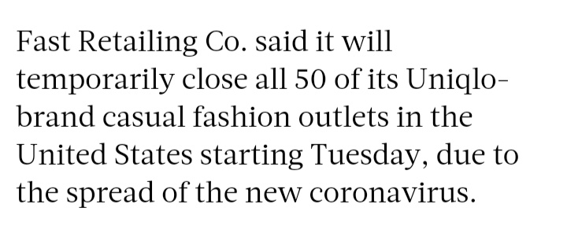
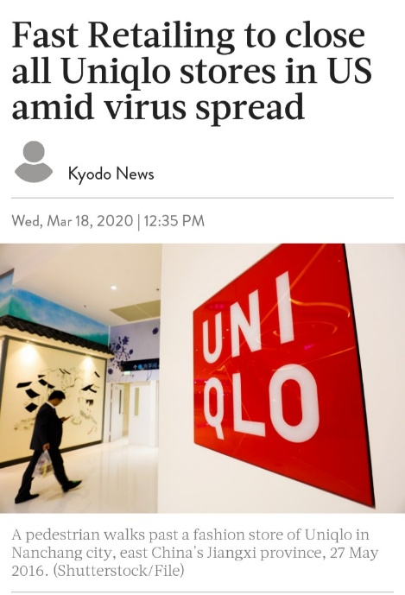

Title Fast Retailing to close all Uniqlo stores in US amid virus spread

Lead Fast Retailing Co. said it will temporarily close all 50 of its Uniqlo-brand casual fashion outlets in the United States starting Tuesday, due to the spread of the new coronavirus.
Analysis
Fast Retailing: Fast Retailing Co.
To close: will temporarily close
All uniqlo stores in US: All 50 of its Uniqlo-brand casual fashion outlets in the United States.
Amid virus spread: due to the spread of coronavirus.

Added Information in the Lead:
- …
- …

