Theme: The Net area of Tension member

- A single line of standard holes for 3/4 in. bolts are placed in a 6x 1/2 plate as shown below. Determine the gross and net areas.
- Determine the net area of an angle profile L 50 x 50 x 5 as shown below. Bolts diameters are 1/2 -in.
- Determine the net area of the tension member as shown below, if the member are : L 8 x 6 x 1/2 and Bolts diameters are 3/4 in.
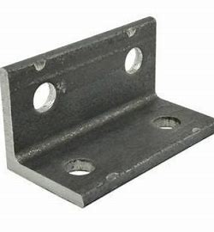
- Determine the net area of the profile C 200 x 70 x 7 as shown below. Bolts diameters are 7/16 -in.
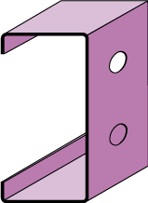

- Determine the net area of the profile IWF 200 x 100 x 5.5 as shown below. Bolts diameters are 5/8 -in.
